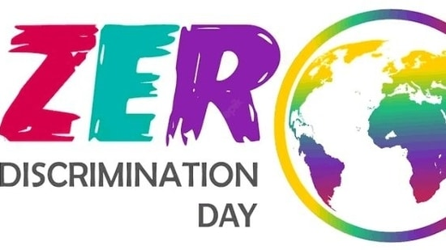

introduction

The day was first celebrated on March 1, 2014 after UNAIDS, a joint United Nations program on Human Immunodeficiency Virus (HIV) and Acquired Immune Deficiency Syndrome (AIDS), launched its Zero Discrimination Campaign on 'World AIDS Day' in December 2013. The then-Executive Director of UNAIDS Michel Sidibé launched the day in 2014 with a major event in Beijing.

Significetion

The day was first celebrated on March 1, 2014 after UNAIDS, a joint United Nations program on Human Immunodeficiency Virus (HIV) and Acquired Immune Deficiency Syndrome (AIDS), launched its Zero Discrimination Campaign on 'World AIDS Day' in December 2013. The then-Executive Director of UNAIDS Michel Sidibé launched the day in 2014 with a major event in Beijing.

Zero Discrimination Day is celebrated to promote equality, inclusion, and tolerance across the globe. Discrimination in any form deeply impacts an individual. It also violates human rights, and creates barriers to

accesseducation, healthcare, and job opportunities, which eventually perpetuates poverty and inequality.

According to the UNAIDS, “Criminalisation drives discrimination and structural inequalities. It robs people of the prospect of healthy and fulfilling lives and it holds back the end of AIDS. We must end criminalisation to save lives.”

**Happy International Day of Happiness 2024:**

The International Day of Happiness (also known as World Happiness Day) falls annually on March 20. As the name suggests, the International Day of Happiness is a day to be happy because happiness is a fundamental human goal. International Day of Happiness was first observed in 2013 by the United Nations. According to the United Nations website, it recognizes this fundamental goal and calls for "a more inclusive, equitable and balanced approach to economic growth that promotes the happiness and well-being of all peoples." Additionally, the UN also urges nations to create a space for the happiness of their citizens.

\ 